Assignment-15.4
Name: PENNA BHARGAVI
H.No:2303A52391
Batch:44
Task 1: Initial API Setup for a Service Platform
Prompt:
Generate a basic Flask application in Python.
Requirements:
- Create a Flask app.
- Add a route '/status'.
- The route should return a JSON response: {"status": "API is running"}.
- Run the app on localhost with debug mode enabled.
- Keep the code simple and beginner-friendly.
Code:

Observation:
1. The Flask application was successfully created and executed.
2. The server started without any errors in VS Code.
3. The /status endpoint was tested using a browser.
4. The API returned the correct JSON response.
5. This confirms that the backend service is running properly

Task 2: Create API to Add and View Resources
Prompt:
Generate a Flask API in Python.
Requirements:
- Create an in-memory list to store service requests.
- Implement a GET endpoint '/requests' to retrieve all requests.
- Implement a POST endpoint '/requests' to add a new request.
- Each request should contain 'title' and 'priority'.
- Return responses in JSON format.
- Keep the code simple and beginner-friendly.
Code:

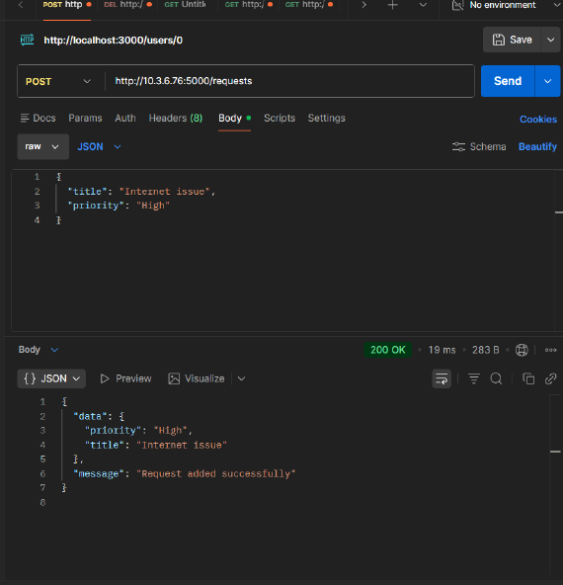

Observation:
- The Flask API was successfully developed and executed in VS Code.
- Initially, the GET request to /requests returned an empty list.
- A POST request was used to add a new service request with title and priority.
- The API returned a confirmation message along with the added data.
- After adding data, the GET request returned the stored service request.
- This confirms that both GET and POST endpoints are functioning correctly.
- The data is stored temporarily in memory and is lost when the server restarts.

Task 3: Modify Existing Resource Using AI Assistance
Prompt:
Generate a Flask API in Python.
Requirements:
- Maintain an in-memory list of service requests.
- Each request contains 'title' and 'priority'.
- Implement a PUT endpoint '/requests/<int:index>' to update a request by index.
- If index is valid, update the request and return:
{"message": "Request updated", "request": updated_object}
- If index is invalid, return a JSON error message with HTTP status code 404.
- Keep the code simple and beginner-friendly.
Code:

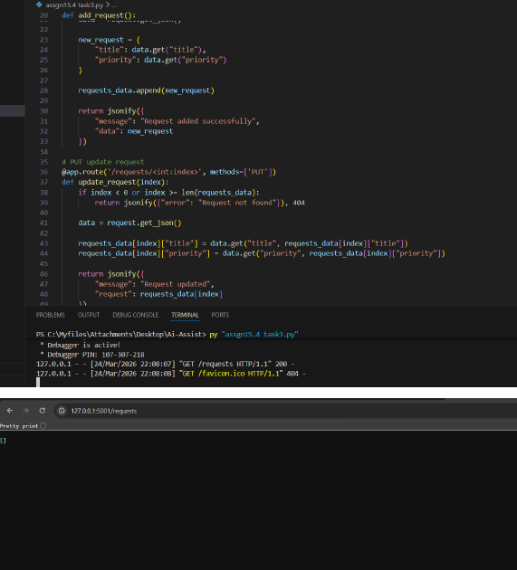

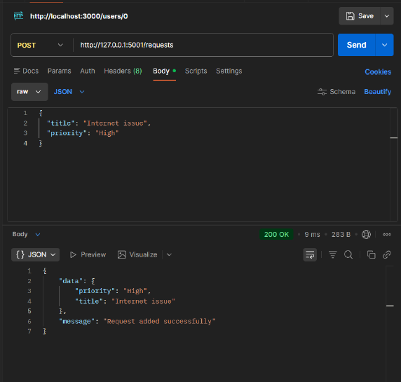
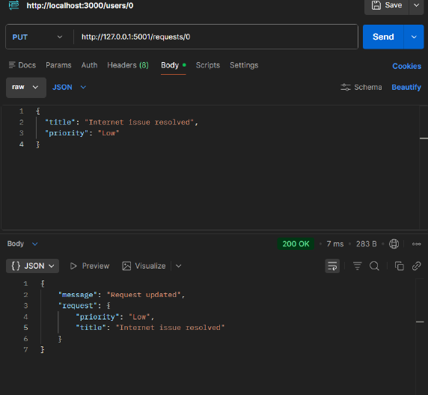

Observation:
- The PUT endpoint was successfully implemented to update service requests.
- When a valid index was provided, the request was updated correctly.
- The API returned a confirmation message along with the updated data. When an invalid index was used, the API returned a proper error message.
- The error response included HTTP status code 404, ensuring proper error handling.
- This confirms that the update functionality works correctly and handles edge cases.

Task 4: Remove a Resource Safely
Generate a Flask API in Python.
Requirements:
- Maintain an in-memory list of service requests.
- Each request contains 'title' and 'priority'.
- Implement a DELETE endpoint '/requests/<int:index>' to remove a request by index.
- If index is valid, delete the request and return:
{"message": "Request deleted", "request": deleted_object}
- If index is invalid, return a JSON error message with HTTP status code 404.
- Ensure the server does not crash on invalid input.
- Keep the code simple and beginner-friendly.
Code:

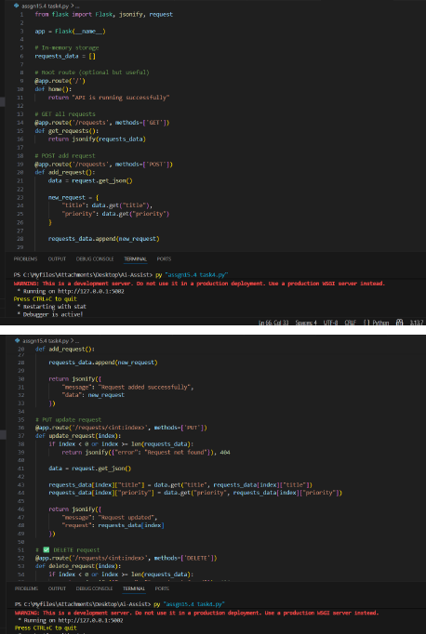
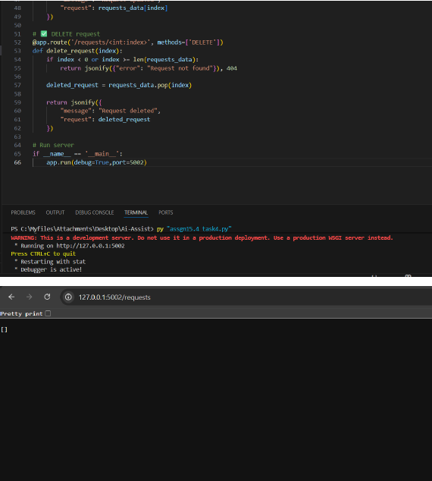
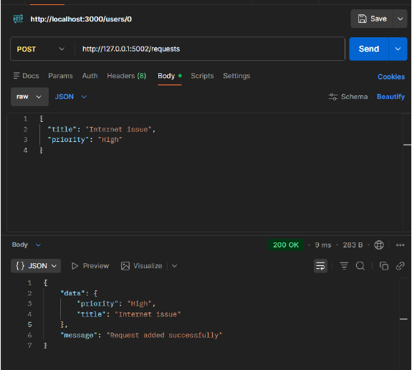
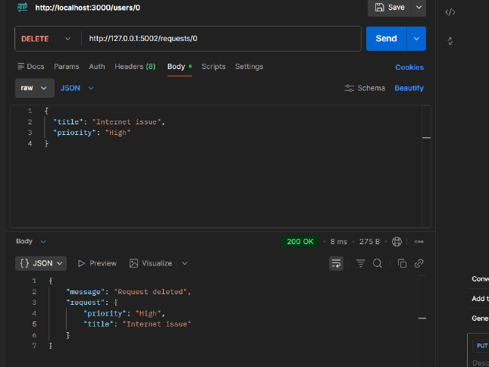
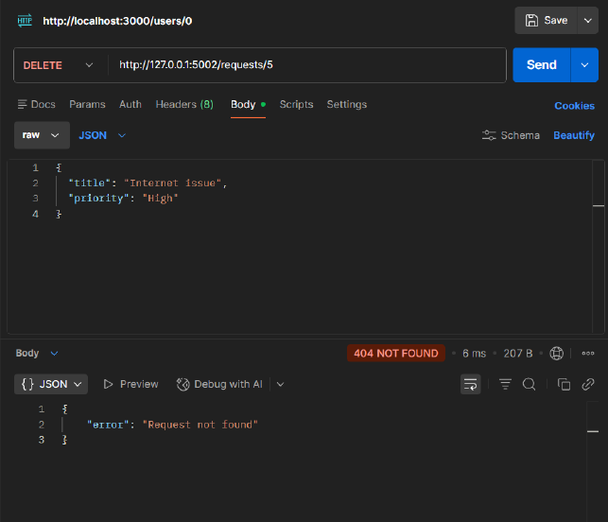

Observation:
1.The DELETE endpoint was successfully implemented to remove service requests.
2.When a valid index was provided, the request was deleted correctly.
3.The API returned confirmation along with the deleted request details.
4.When an invalid index was used, the API returned an appropriate error message.
5.The server handled invalid input gracefully without crashing.
6.This confirms proper functioning of the DELETE operation and error handling.

Task 5: AI-Assisted API Documentation and Readability
Prompt:
Enhance a Flask API by adding documentation.
Requirements:
- Add meaningful docstrings to all endpoints.
- Include inline comments explaining the logic.
- Clearly describe HTTP methods, inputs, and outputs.
- Improve code readability for other developers.
- Optionally suggest integration with Swagger or Flask-RESTX for API documentation.
- Keep the code simple and beginner-friendly.
Code:
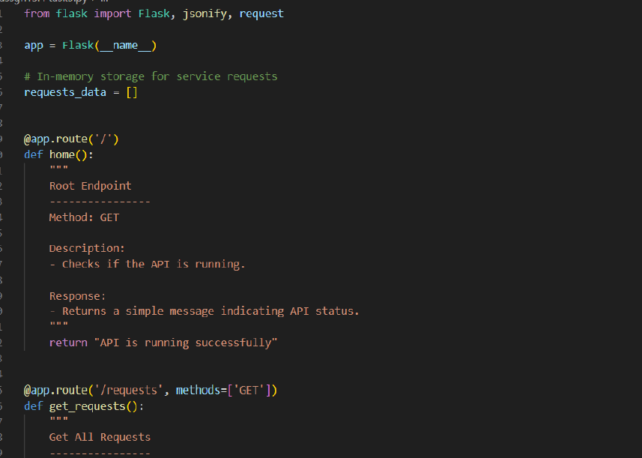
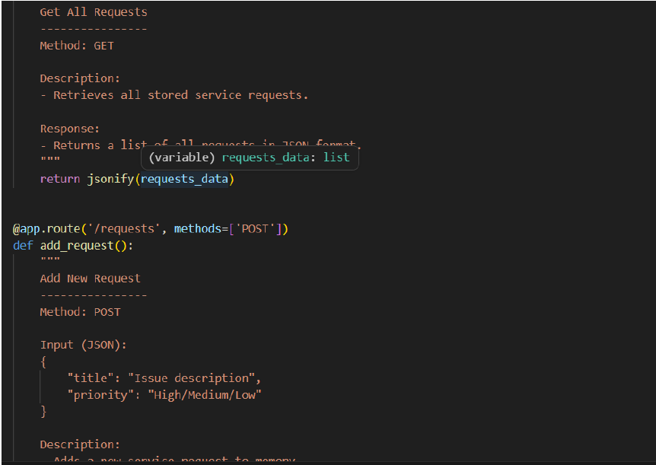
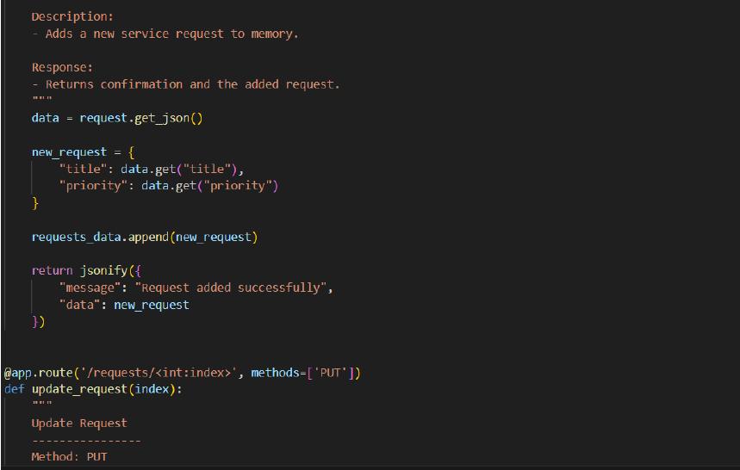
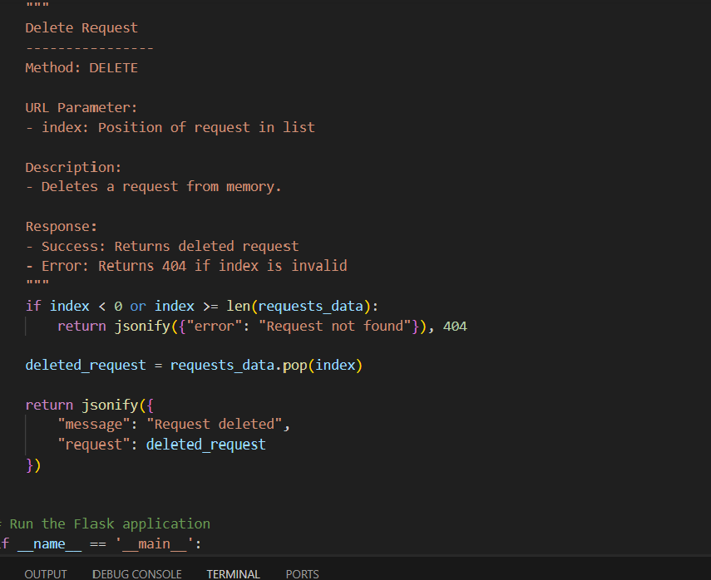Observation:
- Docstrings were added to all endpoints describing functionality, inputs, and outputs.
- Inline comments improved code readability and understanding.
- Each API method (GET, POST, PUT, DELETE) is clearly documented.
- The API is now easier for other developers to use without reading full code.
- Documentation ensures better maintainability and collaboration.
- Optional tools like Swagger can further enhance API usability

